**Introduction to Operational Amplifier**

*4th Revised at Sep. 22. 2010*

**I. Experiment Objective**

Acquaint with the characteristics of simple operational amplifier

**II. Experiment Hint**

**◎ Why do we need Op Amp?**

Signal amplification is one of the most important works in analog circuit. Generally, the amplifier we demand is:

V0=AVVi

AV stands for amplification rate and the value had better be stable. The requirements includes that AV is stable even under different frequency, amplitude, temperature, operating time, and component renewal (mass production or repair).

The frequent used transistors can be used to amplify the signals but lack of the characteristics mentioned above. Because FET and BJT are none linear components, they can not be applied to do linear amplification actually. Many parameters will change according to their own temperature and operation place. Therefore, simple transistors are not capable for accurate amplification for general signal.

Thus, we make use of circuit techniques to integrate hundreds of transistors into a good linear amplifier by mutil-stage. This is so called Operating Amplifier, and the abbreviation is Op Amp. Op Amp is stable for general signals so it can be seen as almost ideal amplifier. Recently, due to the progress of semiconductor techniques, we can integrate well-designed Op Amp as a wonderful effective IC, which is small for convenience and easiness. .

**＊ The symbol of Op Amp is as the figure below:**



+VCC、-VEE are terminals of power supply, but we often ignore this in the circuit scheme. Vo is the output signal while Vi+ and Vi- are input signals.. As for some Op Amps, they have assignments such as Offset Null or Compensation and we sketch and mark in the dotted line section.

Why do two input terminals are necessary? It is because the signals utilize Differential Amplification. Its output voltage （Vo） is the input voltage （Vi­+） minuses the input voltage （Vi-） and then times a gain （AOL）.



Differential Amplification is to make Op Amp application more flexible and easy to use.

**◎ Ideal Op Amp circuit analysis**

Three principles are demanded to analyze a circuit composed of Op Amp.

1. The impedance of both input terminals are regarded as ∞ so that the current can’t flow in.
2. The output impedance is so small as to be considered zero.
3. The open loop gain （AOL）is near ∞. Therefore, under the condition that the output power terminal is not saturated, according to (i), the gap of the two input terminals is almost zero. This phenomenon is called virtual ground.

Amplifier is one of the most common circuits. From the aspect of phase difference of the input signal and the output signal, mainly, we can separate them into non-inverting amp and inverting amp. Owing to the similar operating methods, here we only take noninverting amp as the example.

**Example**



Fig. 3-1 inverting configuration amplifier



Fig. 3-2 equivalent circuit of Fig.3-1

In the circuit of Fig.3-2, V+ and V- can be considered equal. But no current flows into A, thus:



This circuit is called noninverting amp and it is one of the basic circuits of OP. Its amplification rate is equal to the ratio of Rf and R1.

**◎ Practical Op Amp non-ideality**

Real Op Amp has something different with the ideal Op Amp. To accurately hold the Op Amp characters, usually, all errors of Op Amp are marked by some standardized parameters. These parameters are listed in the text book of Electronics in details. Here we only to explain some important items.

（1）Input Offset Voltage

Connect the Op Amp with the power and short the input nodes to ground. You will find that the output voltage terminal is not zero. If zero is needed, we need to add a proper small voltage on the input terminal. This small voltage is called Input Offset Voltage. Input Offset Voltage comes from Op Amp Differential input stage. Although symmetry is demanded during the process of production, due to the unavoidable unbalanced, the transistors on the both sides of the amplifier can not be perfectly symmetrical. Besides, Input Offset Voltage will change because of the temperature and the timing of operation.

（2）Input Bias Current

There will be no current flow into Op Amp for an ideal Op Amp. However, no matter how perfect the Op Amp is, it is unlikely to fully avoid current from flowing into the input terminal. The average current value of the both terminals is Input Bias Current. Input Bias Current flowing through the Resistance V+ and V- will generate a small voltage. A small voltage difference will show on the output terminal after amplification. Usually, chosen suitable Resistance to make equivalent resistor of both terminals equal can avoid the voltage difference.



（3）Input Offset Current

As what (2) described, the difference value of input bias current of both input terminals is Input Offset Current. It is because the transistors in differential gain stage have different β. Input offset current would generate DC offset at output nodes with load resistor of V+ and V-

（4）PSRR（Power Supply Rejection Ratio）

The Open Loop Gain of Op Amp is extremely big. If the power supply connect to the Op Amp contains ripple or noises, the energy of power supply will enter Op Amp and influence the output signals after amplification. This phenomenon results from the bias current, because the current is unlikely to be ideal.

（5）Slew Rate

Under the condition of big signal of Op Amp, the maximum changing rate is called the Slew Rate. Slew Rate comes from interior Op Amp as the compensated capacitor. This capacitor depends on the output current of differential stage. In this way, the output signals will pull up or down the voltage with the signal speed. But during the big signal operation, due to the limited of differential stage current, it is possible to charge or discharge without enough time so that output signals can’t keep up with the input signals.

Regarding more detailed information about Op Amp parameters, please refer to the Millman Electronics chapter 14-6, 14-7, and 14-9, or Smith Electronics 4th edition chapter 2.9 to 2.12.

**Introduction to Operational Amplifier**

**PRELAB (1)**

|  |  |
| --- | --- |
| Class： | Group： |
| Name： | Student ID： |
| Member： | Student ID： |

**◎ Preview 1: Inverting Amplifier**

Assumed that the Op Amp ideal, please refer to the example in the handout to solve the voltage gain Av of circuit in Fig. P1(A).



Fig. P1(A) Noninverting configuration

Please derive the following expression for the closed-loop voltage gain Vo/Vi and explain why we use high input impedance inverting amplifier in Fig. P1(B). Describe the function of T-type circuit composed by R2, R3 and R4.



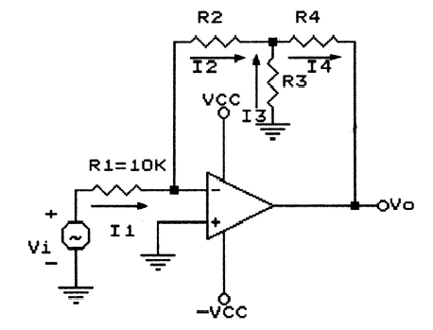

Fig. P1(B) High input impedance inverting amplifier

**◎ Preview 2: Voltage Follower**

Explain the relation between output signal Vo and input signal.

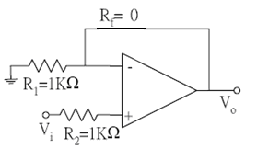

Fig. P2 Voltage Follower

**◎ Preview 3: A Weighted Summer**

Please prove the following equation.





Fig. P3：**A weighted summer**

**◎ Preview 4: Difference Amplifier**

Please derive the following expression of Vo versus V1 and V2 and evaluate the differential input resistance Rin (between node V1 and V2), and describe when we use difference amplifier in Fig.P4.



Drawing1

Fig.P4 Difference Amplifier

**Introduction to Operational Amplifier**

**LAB (1)**

The application of Op Amp is extensive. In addition to the non-inverting amp, inverting amp, integrator, voltage follower, comparator, Op Amp stands essential position in complicated circuits. Besides the basic circuit, we are going to illustrate some complex applied circuits. The purpose is that the students can understand more about the diversity of Op Amp. These practical circuits can be developed into more complicated and interesting system. If you are interested in this area, it is suggested that you can do it by yourself.

**◥ Experiment 1: Non-inverting Amp. vs. Inverting Amp.**

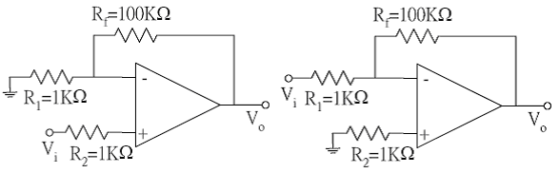

Fig. E1 (a) Non-inverting configuration Fig. E1 (b) Inverting configuration

（1）The connection of circuits is shown as Fig. E1(A), The power supply is ±15V（All the practices are the same.）。 Before adding Vi, please measure Vo and record it. Please explain why Vo is not zero.

（2）Vi is a sine wave with 500Hz frequency and 50mV amplitude. Record Vi and Vo on graph paper and calculate voltage gain. Compare the results with the PRELAB.(1 pic)

*（3）Connect a mega-ohms of variable resistor Rtest ahead of R2 in series and add Vi’ as a 1V amplitude and 100Hz sine wave. Adjust the resistance to make the origin node voltage Vi be half of Vi’ and then Rtest=Rin. (1 pic)

（4）The connection of circuits is shown as Fig.E1 (b). Please find out the Av theoretical value of the voltage gain.

（5）Vi is a sine wave with 500Hz frequency frequency and 50mV amplitude. Record Vi and Vo on graph paper and calculate voltage gain. Compare the results with the PRELAB. (1 pic)

（6）Change the frequency to 5kHz, 50kHz, and 500KHz. Record the voltage gain under these frequencies. (3 pic)

（7）By using the triangular and square waveforms with frequencies of 5kHz, and 50kHz. Observe and plot input and output waveforms. (4 pic)

（8）Connect a kilo-ohms of variable resistor Rtest ahead of R1 in series and add Vi’ as a 100mV amplitude and 100Hz sine wave. Adjust the resistance to make the origin node voltage Vi be half of Vi’ and then Rtest=Rin. (1 pic)

（9）Compare the difference between non-inverting amp and inverting amp.

（10）Use the circuit in Fig. E1 (c) to design an inverting amplifier with a gain about 100 and input resistance of 100kΩ, Vi is a sine wave with 500Hz frequency and 50mV amplitude. Record Vi and Vo on graph paper and calculate voltage gain. Compare the results with the PRELAB. (1 pic)



Fig. E1 (c) High input impedance inverting amplifier

**◥ Experiment 2: Voltage Follower**

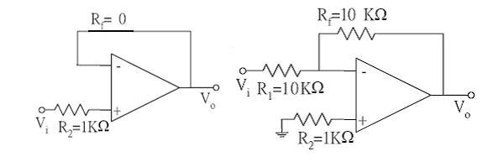

Fig. E2(a) Voltage Follower Fig. E2(b) Inverting configuration

1. The connection is as Fig. E2(a)。
2. Vi is a sine wave with 500Hz frequency and 5V amplitude. Record Vi and Vo on graph paper and calculate voltage gain. Compare the results with the PRELAB. (1 pic)
3. The connection is as Fig. E2(b). Find the ideal voltage gain.
4. Vi is a sine wave with 500Hz and 5V amplitude. Record Vi and Vo on graph paper and calculate voltage gain. Compare the results with the PRELAB. (1 pic)
5. Compare Fig. E2(a) with Fig. E2(b)。

**◥ Experiment 3: A Weighted Adder**



Fig.E3 A weighted adder

1. V1 is a square wave with frequency of 100 Hz and amplitude of 150 mV. V2 is a square wave with frequency of 100 Hz and amplitude of 50 mV. Please sketch the input signals and output signals of these three waves. Compare the results with preview 3. (1 pic)

**◥ Experiment 4: Difference Amplifier**

1. The connection of circuits is shown as Fig E3(a), where R1= R2= R2=R4=1KΩ.
2. V1 is a square wave with frequency of 100 Hz and amplitude of 150 mV. V2 is a square wave with frequency of 100 Hz and amplitude of 50 mV. Please sketch the input signals and output signals of these three waves. Compare the results with preview 4. (1 pic)

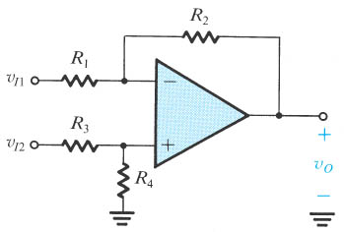

Fig.E4 Difference Amplifier

**Introduction to Operational Amplifier**

**REPORT (1)**

**◥ Experiment 1: Non-inverting Amp. vs. Inverting Amp.**

(1) VO(offset)=

(2) Vo vs. Vi (1 pic)

Av=

(3)Rin=

(4)Av(ideal value)=

(5) Vo vs. Vi (1 pic)

Av=

(6) (3 pic)

|  |  |  |  |
| --- | --- | --- | --- |
|  | 5k Hz | 50k Hz | 500k Hz |
| Av |  |  |  |

(7)Output of triangular and square wareforms **(4 figures)**

|  |  |  |
| --- | --- | --- |
| Av | 5k Hz | 50k Hz |
| Triangular wave |  |  |
| Square wave |  |  |

(8)Rin=

(9) Compare the difference between the non-inverting amp and inverting amp.

(10) Vo vs. Vi (1 pic)

R2 = R3 = R4 = Av = (Theoretical)

Rin=

Av = (real)

**◥ Experiment 2: Voltage Follower**

(2) Vo vs. Vi (1 pic)

Av=

(3)Av(ideal value)=

(4) Vo vs. Vi (1 pic)

Av=

(5)Compare the difference

**◥ Experiment 3: A Weighted Adder**

(1) (1 pic)

V1 input wave

V2 input wave

Vo output wave

V1、V2、Vo equation？

**◥ Experiment 4: Difference Amplifier**

(2) (1 pic)

V1 input wave

V2 input wave

Vo output wave

V1、V2、Vo equation？